Chapter 19 #6-10

6.

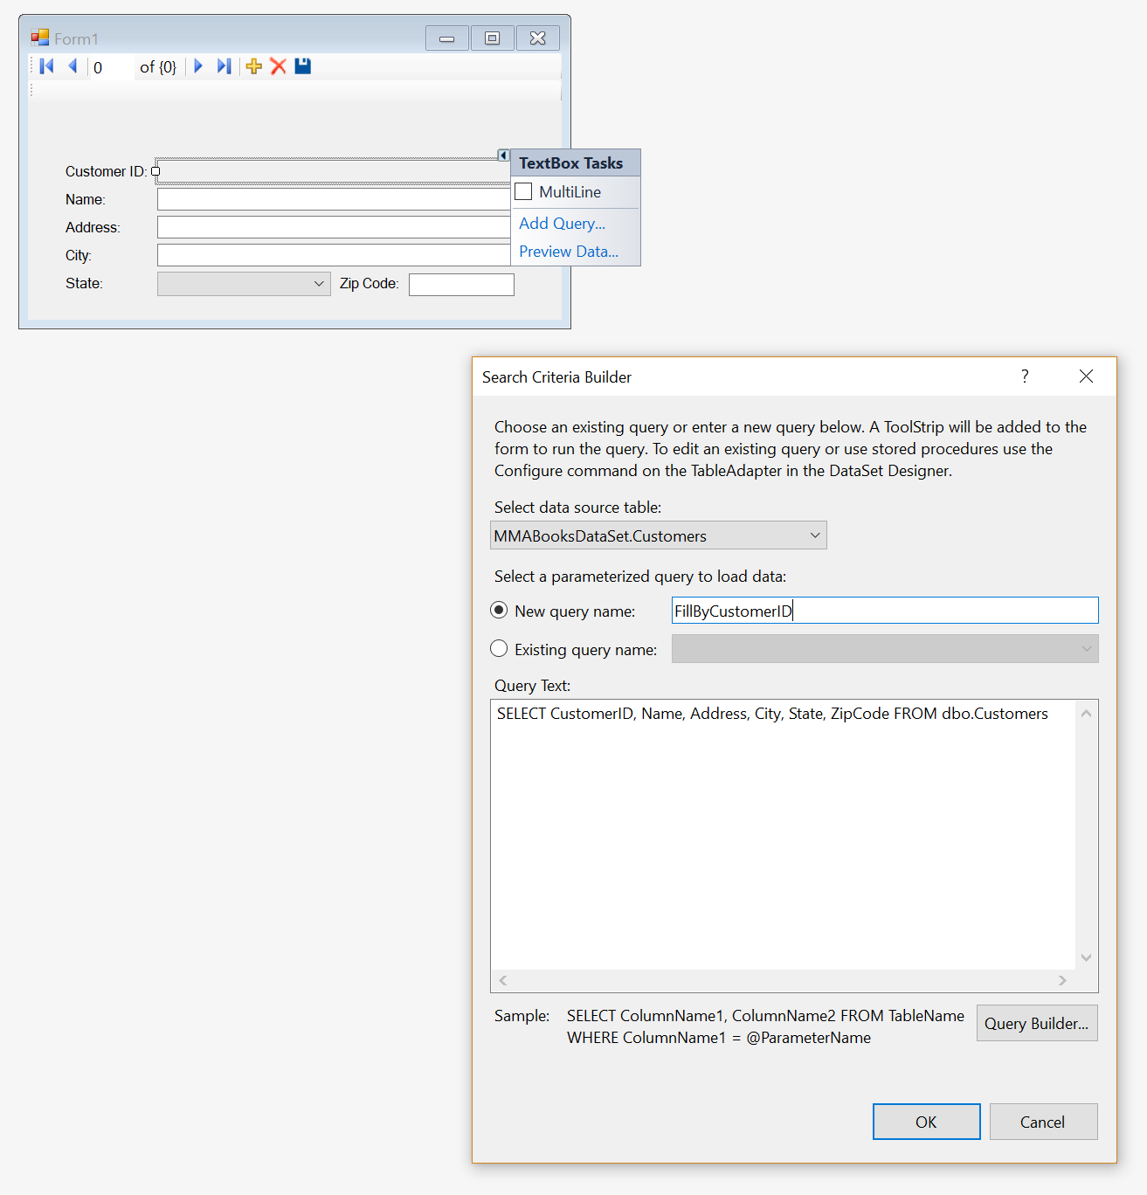

private void fillByCustomerIDToolStripButton_Click(object sender, EventArgs e)

{

try

{

this.customersTableAdapter.FillByCustomerID(this.mMABooksDataSet.Customers, ((int)(System.Convert.ChangeType(customerIDToolStripTextBox.Text, typeof(int)))));

}

catch (System.Exception ex)

{

System.Windows.Forms.MessageBox.Show(ex.Message);

}

}

6b. 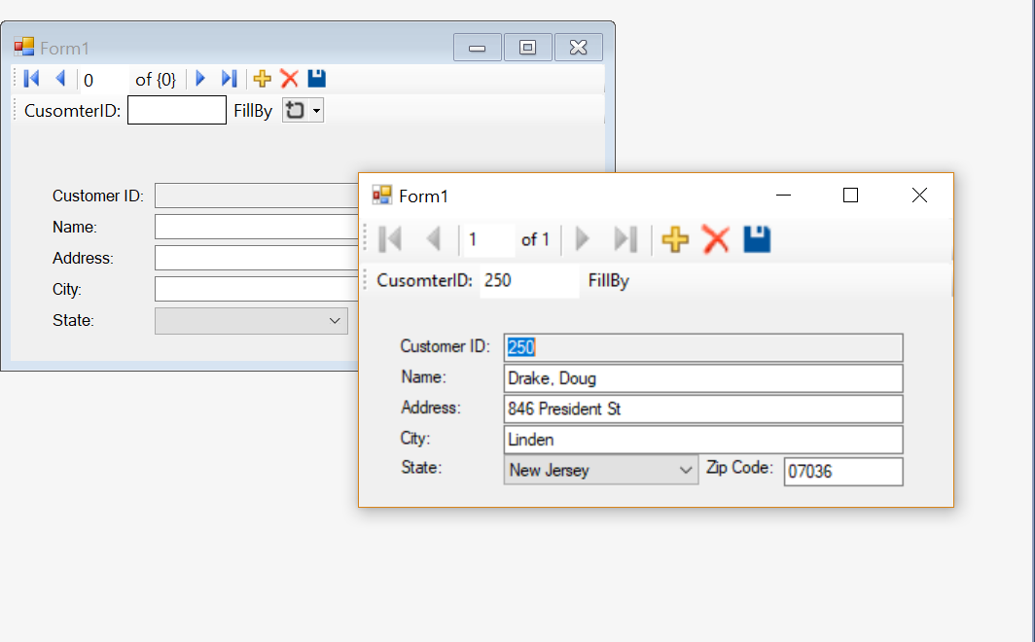

7. 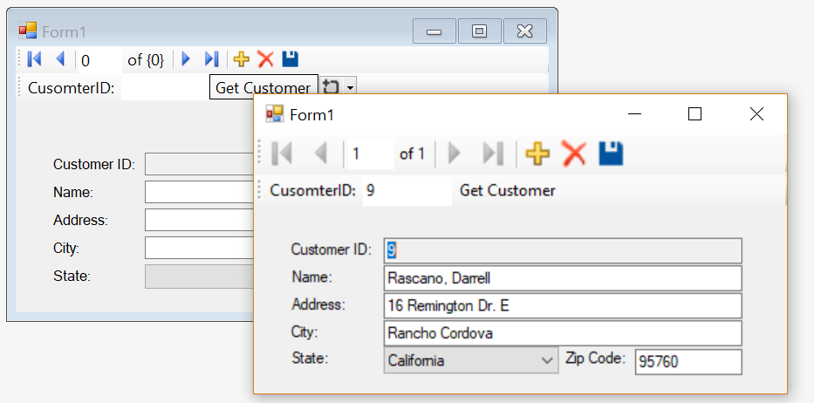

8. 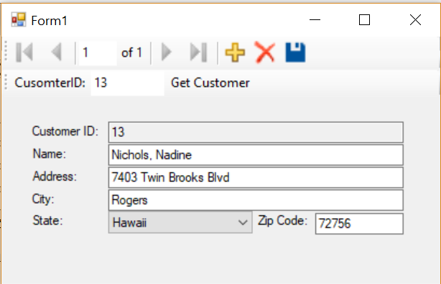

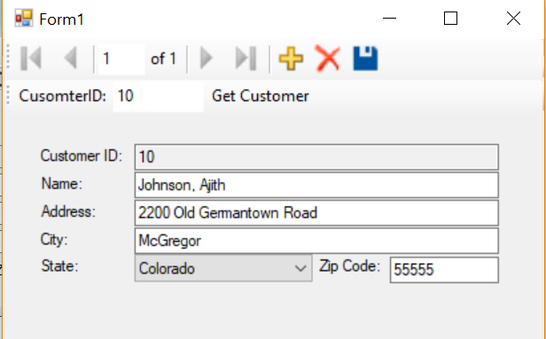

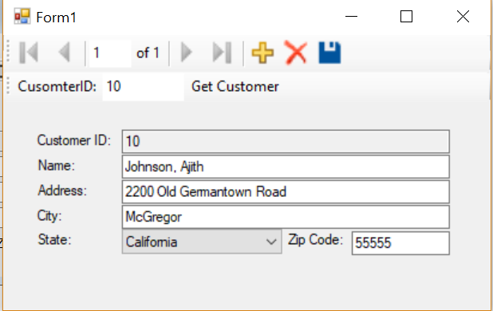

9. 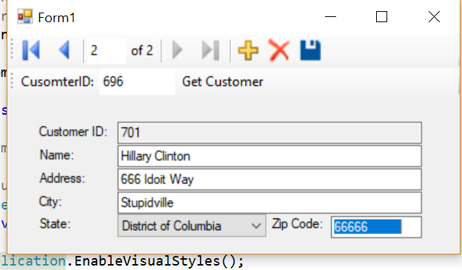

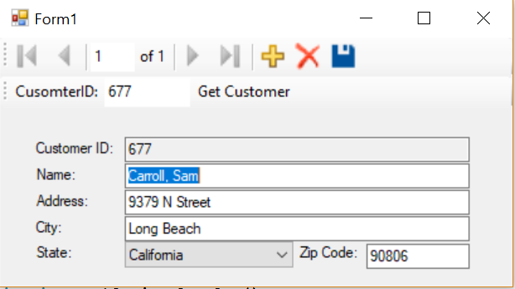

10. 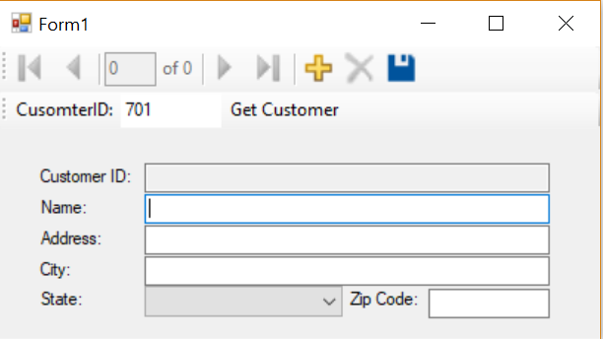

I did not have to type any code for this assignment. Visual studio inserted the one bit of code that was needed.